

**Mehran University of Engineering Technology Jamshoro, Jamshoro**

**Department of Software Engineering**

**21 Batch 6th Semester regular 2024**

**Mobile Application Development - Theory**

**CEP Software Project Report**

**Assigned by: Ms. Mariam Memon**

**Prepared by:**

**Ahmed Ali 21_20sw82**

**Khushal Rathore 21sw014**

**Nikhil 21sw54**

**Report on the Digital Crime Reporting Application:**

**Introduction:** Digital Crime reporting App is a revolutionary Digital Crime Reporting Application designed to make reporting crimes simpler and more accessible for everyone—from everyday citizens to law enforcement officers. By bridging the gap between the public and the police, Digital Crime reporting App aims to enhance safety and security in our communities.

**Features:**

1. **User-Friendly Interface:** The app boasts an intuitive interface that guides users step-by-step through the crime reporting process. Users enter their personal information, like name, contact details, and address, making it straightforward to submit reports. This thoughtful design ensures that law enforcement receives all the necessary details without any hassle.
2. **Login and Authentication:** Digital Crime reporting App offers a secure login system with options for public users and law enforcement officers (“Login as Cop”). This dual access feature means that sensitive information is managed appropriately, ensuring that only authorized users can submit or review reports. Users log in with their email and password, adding an extra layer of security.
3. **Crime Reporting Process:** Once logged in, users can fill out a detailed form to report any crime or offense they've witnessed. This includes sections for describing the incident, ensuring that all relevant details are documented. The app aims to ease the reporting burden for both users and law enforcement, leading to more accurate and comprehensive reports.
4. **Contact and Support:** Digital Crime reporting App includes a dedicated support section, offering users easy access to help if they encounter issues. Users can reach out via email (support@crimedetector.com) or by calling the helpline (6380381945). This support ensures a smooth user experience and fosters confidence in the app.
5. **Safety and Security:** The app takes user privacy seriously. Sensitive information, such as Aadhar numbers, is carefully protected, ensuring that users can report crimes without fear of compromising their personal details. Digital Crime reporting App empowers individuals to take action against crime, making communities safer through the use of technology.

**USER INTERFACE OF APP:**

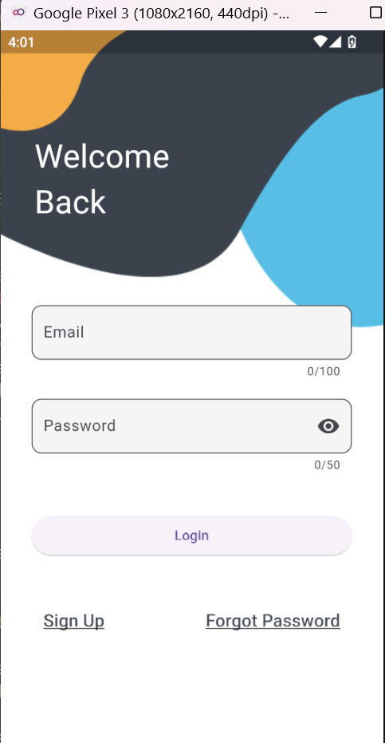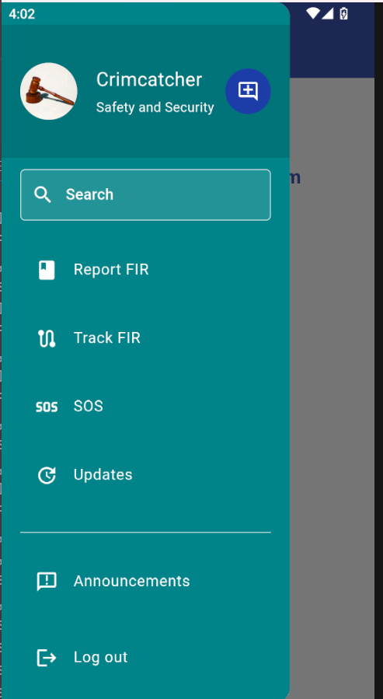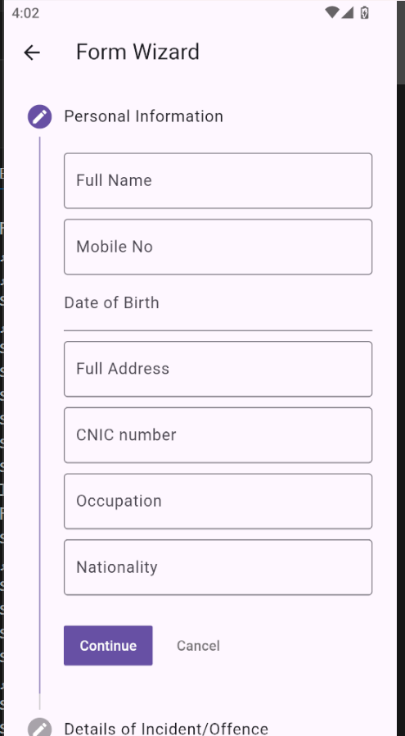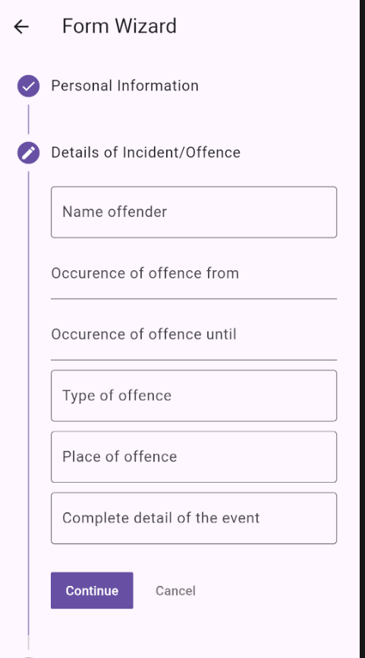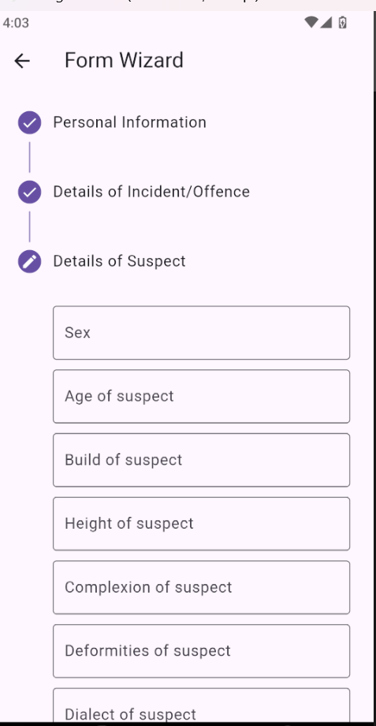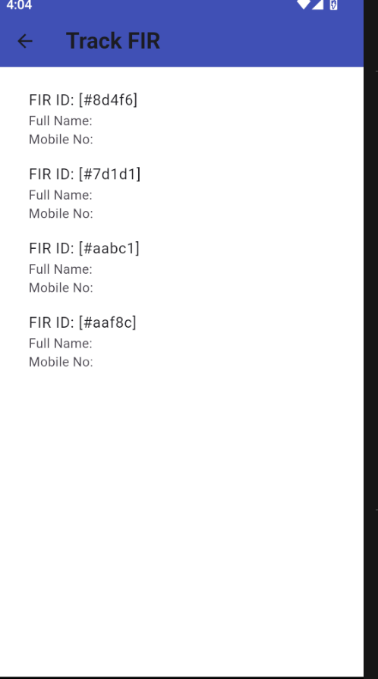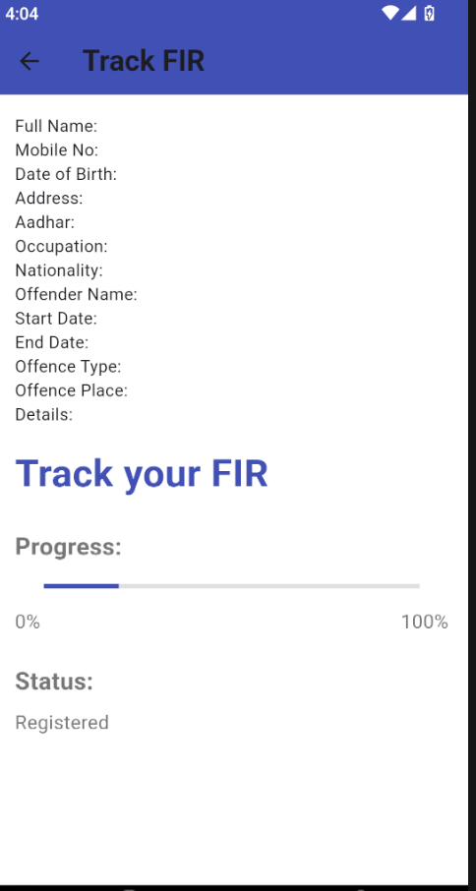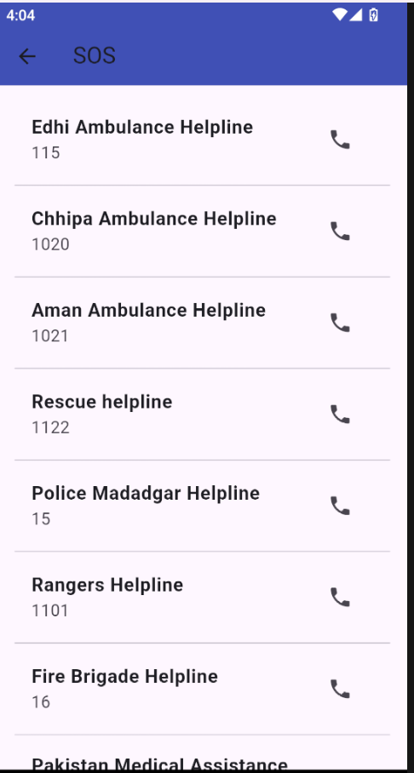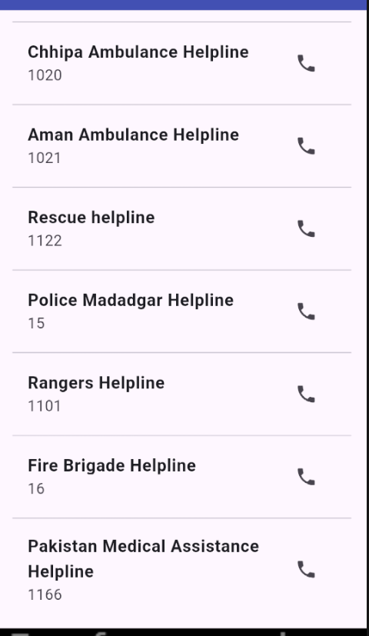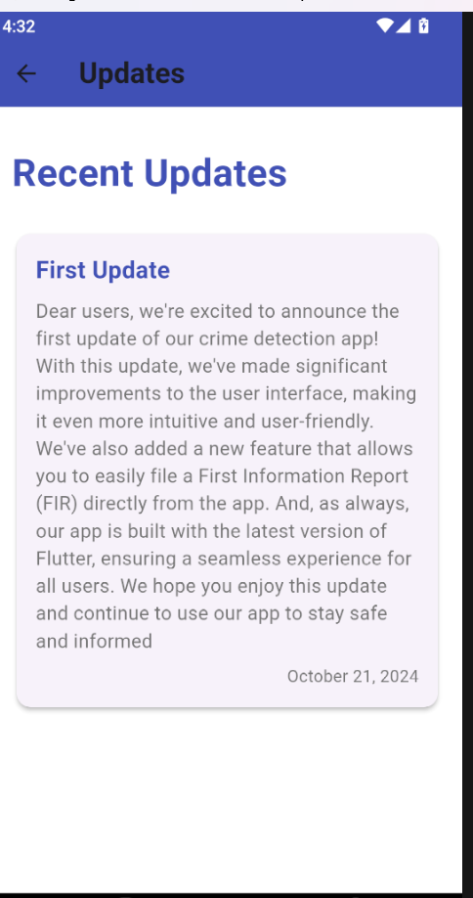

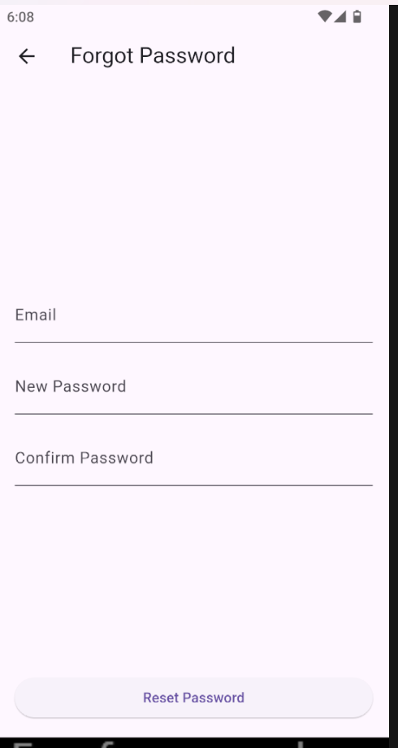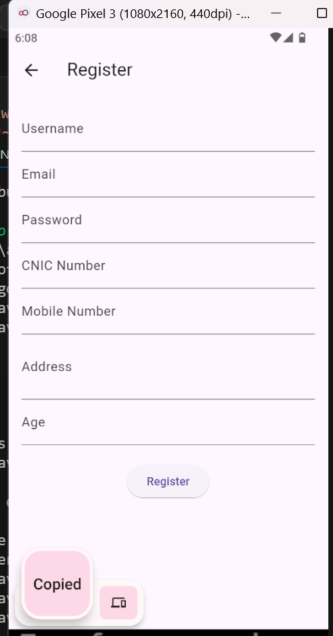

**Conclusion:** In conclusion, Digital Crime reporting App stands out as a vital tool in the ongoing fight against crime. With its user-friendly design, secure login options, and thorough reporting process, it serves as an effective platform for both the public and law enforcement. By simplifying crime reporting and facilitating direct communication with authorities, Digital Crime reporting App contributes to building safer and more responsive communities.

**The End**